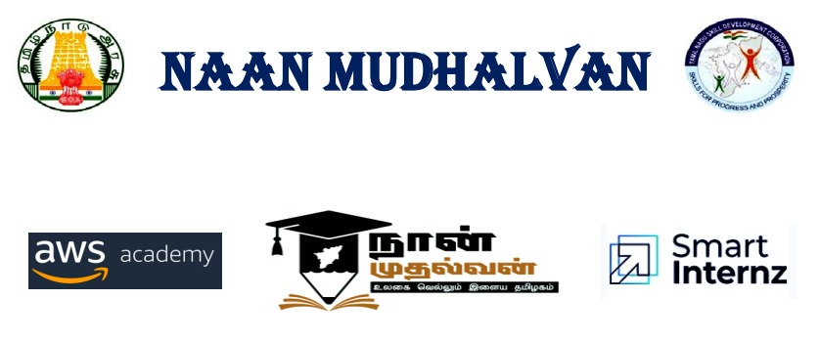

PROJECT TITLE:

BLOOD BRIDGE (Scenario 2: Regular Donor Management)

PROJECT CREATED BY

KARANKUMAR.V – 412622243011

NAMASIVAYAM S - 412622243016

MARIA ROSE.T - 412622243012

SIVAPRIYA. K -412622243009

PROJECT REVIWED BY

PROJECT CREATED DATE: 21 DEC 2024

PROJECT CODE:

COLLEGE CODE: 4126

TEAM NAME: VICTORY WINGS

**ANNA UNIVERSITY: CHENNAI 600 025**

**BONAFIDE CERTIFICATE**

Certified that the mini-project work entitled “BLOOD BRIDGE (Scenario 2: Regular Donor Management)” is a Bonafide work carried out by

KARANKUMAR.V (412622243011)

NAMASIVAYAM (412622243016)

MARIA ROSE.T (412622243012)

SIVAPRIYA (412622243009)

The report has been approved as it satisfies the academic requirements in

respect of mini-project work prescribed for the course.

……..………………………………. ……………………………………….

Internal Guide Head of the Department

Submitted for the Anna University Project Viva-Voce Examination held on

……………………

Internal Examiner External Examiner

**TABLE OF CONTENTS**

1.INTRODUCTION

1.1 OVERVIEW OF LIFELINK SYSTEM

2.OBJECTIVE

3.BLOODBANK AND DONOR

4.DONOR DATABASE

5.SYSTEM FEATURES

6.IMPLEMENTATION DETAILS

6.1 **AWS EC2** CONFIGURATION FOR APPLICATION

6.2 **AWS RDS** CONFIGURATION FOR MYSQL

6.3 FRONT END AND BACK END INTEGRETION

7.TESTING AND OPTIMIZING

7.1 FUNCTION TESTING

7.2 DATABASE APPLICATION

7.3 LOAD TESTING

7.4 SECURITY TESTING

8. CONCLUSION

9.REFERENCE

**1.INTRODUCTION:**

Blood donation plays a critical role in saving lives, yet maintaining a consistent and efficient supply of blood for local hospitals can be challenging. Life Link, a donor management platform, addresses these challenges by streamlining the process for both donors and organizers

In this scenario, John, a regular blood donor, demonstrates how Life Link simplifies donor management. After logging in, he accesses his personalized dashboard to track his donation eligibility. The platform also informs him of nearby blood drives, enabling him to schedule his next donation effortlessly.

This system not only enhances donor engagement but also ensures a reliable supply of blood to meet medical needs. By leveraging technology, LifeLink creates a seamless connection between donors and blood banks, fostering a more efficient and impactful donation process.

Blood donation is a vital activity to save lives, but managing donor schedules and maintaining a consistent blood supply can be challenging. The Regular Donor Management System, built on AWS EC2 and branded as "Life Link," simplifies this process for donors and organizers. In this scenario, John, a regular donor, logs in to check his donation eligibility through an intuitive dashboard. He also discovers a nearby blood drive listed in the system and schedules his next donation. This platform fosters seamless coordination between donors and blood banks, ensuring timely donations and a steady supply of blood to meet local hospital needs.

**1.1Overview of the LifeLink System:**

LifeLink is an innovative donor management platform designed to streamline blood donation processes. By leveraging modern technology, including cloud-based services like AWS EC2, the system provides an intuitive interface for regular blood donors, blood banks, and healthcare organizations.

In view of this, we proposed and implemented a working system of blood bank service which ensures patients get quick access to blood donors of any type whether volunteer donors, replacement donors (family or friends), or compensated donors, in each case, mutual interest is protected. This system is designed to thrive even in the remotest of area sand easy for both young and old because it adopts the use of Unstructured Supplementary Service Data or USSD code, Short Message Service(SMS) and free toll line which makes the system available for both online and ofﬂine database queries. Our initial results show that, if this system is fully implemented, effective blood transfusion services will be in quick improvement in Nigeria and by extension Africa. Index Terms—blood bank, donors, WHO safe blood requirements, unsafe blood transfusion, blood donation management system. The requirement for the blood is an important factor in contemporary medicine and health care. For every second there will be an individual who needs blood to save life.[1] Blood transfusion is a life–saving intervention that has an essential role in the total patient management within health care systems. Over 4 million people are affected with infected with Human Immune Virus(HIV) by unsafe blood transfusion, 99% of 500,000women die yearly with hemorrhage during pregnancy

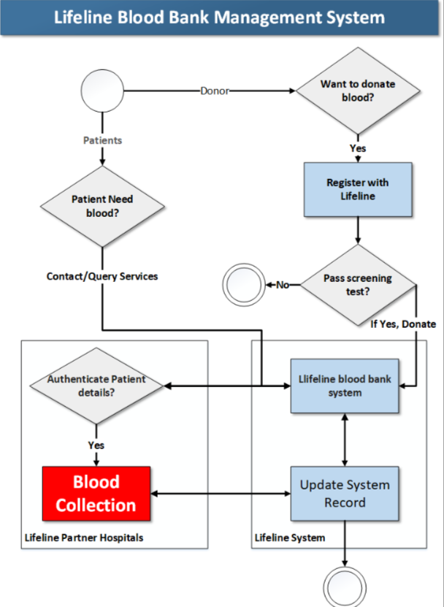

**2.OBJECTIVES:**

The Regular Donor Management scenario within the LifeLink system demonstrates how technology can be leveraged to enhance the blood donation process, making it more efficient and effective for both regular donors and healthcare institutions. The primary objective is to streamline and automate various aspects of blood donation management, fostering a consistent and reliable supply of blood for hospitals.

**Simplified Donation Eligibility Tracking:**

A core objective of the LifeLink system is to make it easier for donors like John to track their donation eligibility. By providing a personalized dashboard that displays the donor’s eligibility status and donation history, the system reduces confusion and ensures donors know when they are eligible to donate again. This eliminates the need for donors to manually track their donation intervals, which can sometimes lead to missed opportunities or over-donations. This feature not only improves convenience but also ensures that the donor remains compliant with safe donation intervals, adhering to the guidelines established by medical professionals

**Ensuring a Steady Blood Supply:**

At the heart of the LifeLink system is the goal to maintain a consistent and steady blood supply for local hospitals. By facilitating easier tracking, scheduling, and engagement, the platform supports a well-maintained donor database, reducing the likelihood of shortages. Hospitals and blood banks can rely on the system to keep donors informed and engaged, ensuring that there is always a sufficient amount of blood available for patients in need.

**3. BLOOD BANK AND DONAR:**

Blood banks communicate with donors through a variety of methods to ensure a steady supply of blood and maintain donor relationships. Here’s a breakdown of how this communication typically works:

**Registration and Initial Contact:** After a donor registers with the blood bank, the bank collects essential contact details (phone numbers, email addresses) for future communication. The donor is informed about the donation process, eligibility criteria, and the importance of regular donations.

**Donor Reminders:** Blood banks often send reminders to donors when they are eligible for their next donation, typically every 8 to 12 weeks, depending on the type of donation. This can be done through text messages, emails, or calls, ensuring that the donor stays engaged.

**Donor Health Status Updates:** After donating blood, donors receive updates on the safety and use of their blood. If the blood is used for a patient, donors may be informed (if applicable). Blood banks may also notify donors about the results of tests performed on their blood (e.g., for infectious diseases).

**Special Requests and Appeals:** When the blood supply is low or there’s a special need (like in emergencies or for rare blood types), blood banks may send out urgent appeals to regular donors via social media, SMS, or phone calls to encourage immediate donations.

**Thank You and Recognition:** Blood banks often send thank-you messages, recognition certificates, or organize donor events to express appreciation, fostering a sense of community and encouraging continued donations

**4.DONAR DATABASE:**

All hospitals and blood banks are handled the blood donor database in this database the patient will also see in the online websites and mobile apps.

If we need any blood group we can search the donor in friends2support website this is also has the mobile app.

In this website is handled the all over world blood donor database just you will entry your country name and State and the District

Here the steps to request to the donor for the blood………..

I

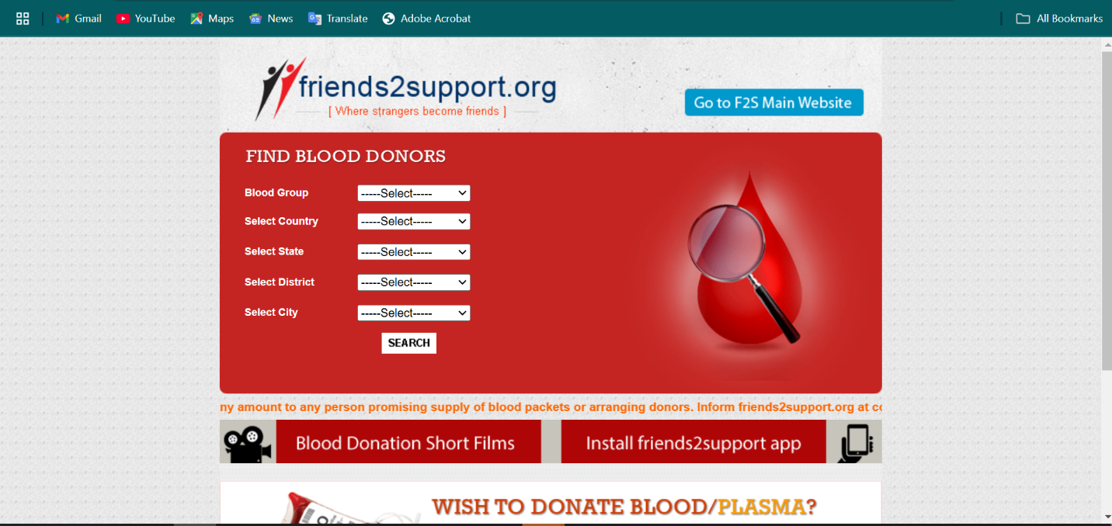 Fig 4.1

It is the first steps to request for blood. First step you will open the website and just register the website for the suitable blood.

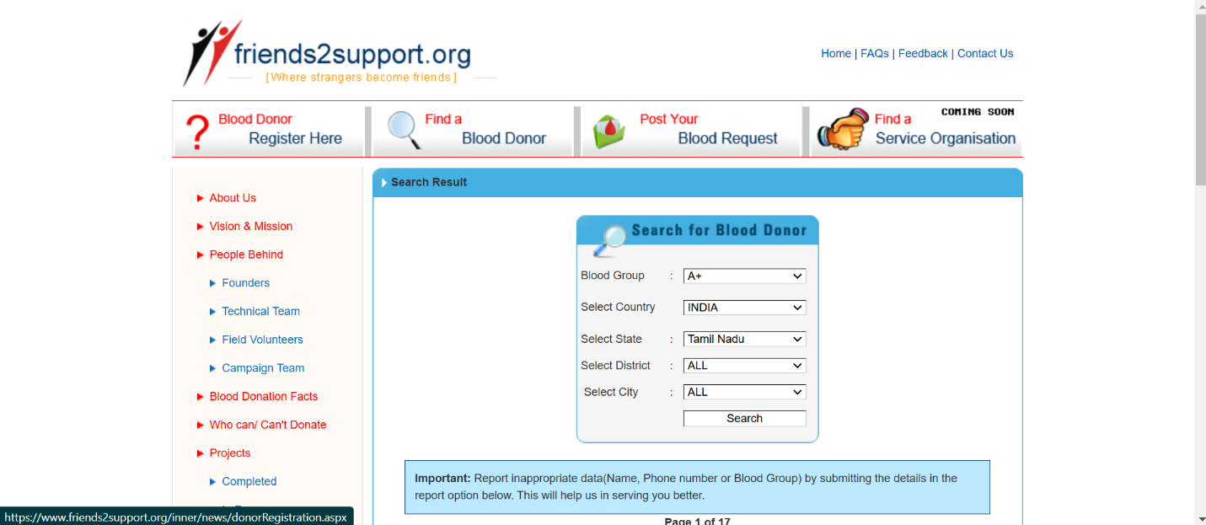 Fig 4.2

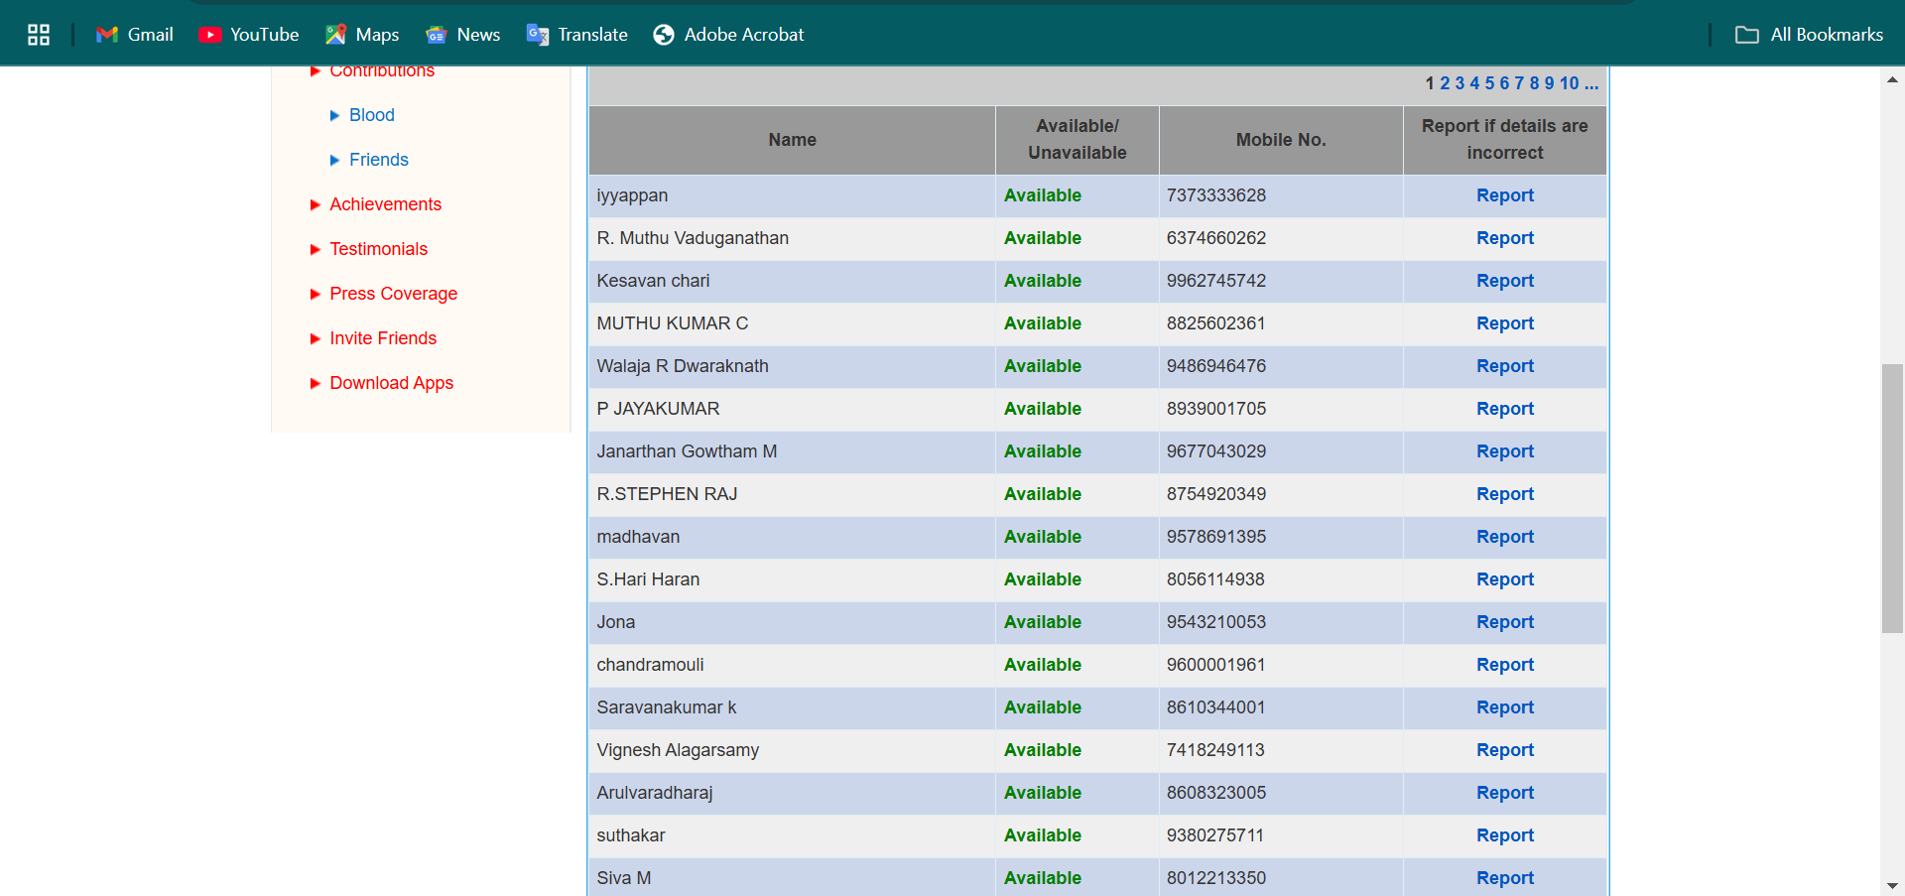

Fig4.3

After register in friends2support you will collect the data in particular district database for your requested blood group.

If the donor need to register means then will apply in lifelink website.

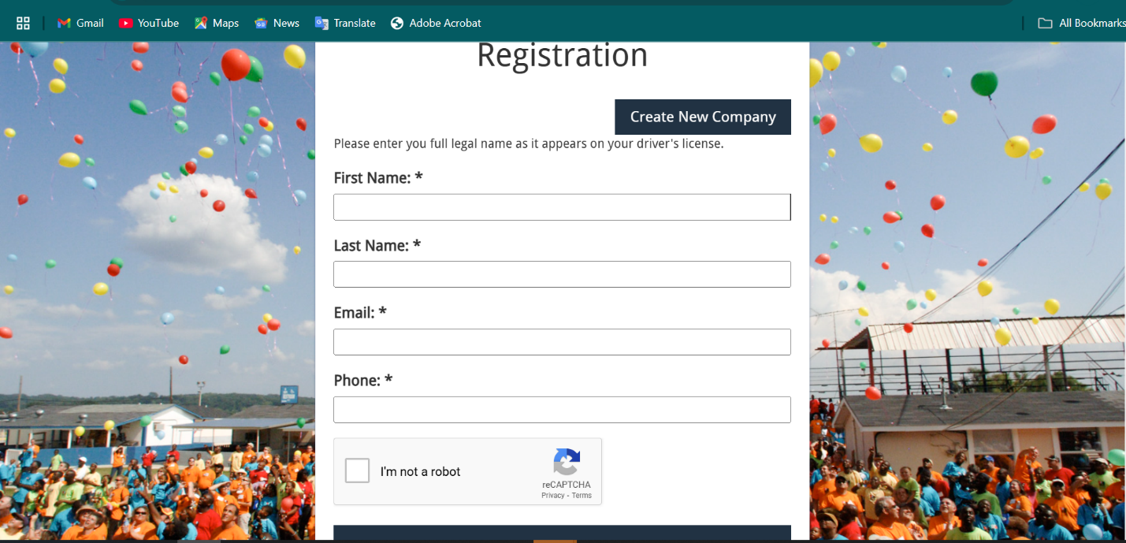

Fig 4.3

It is the registration website for blood donors. Here they will register for donate the blood

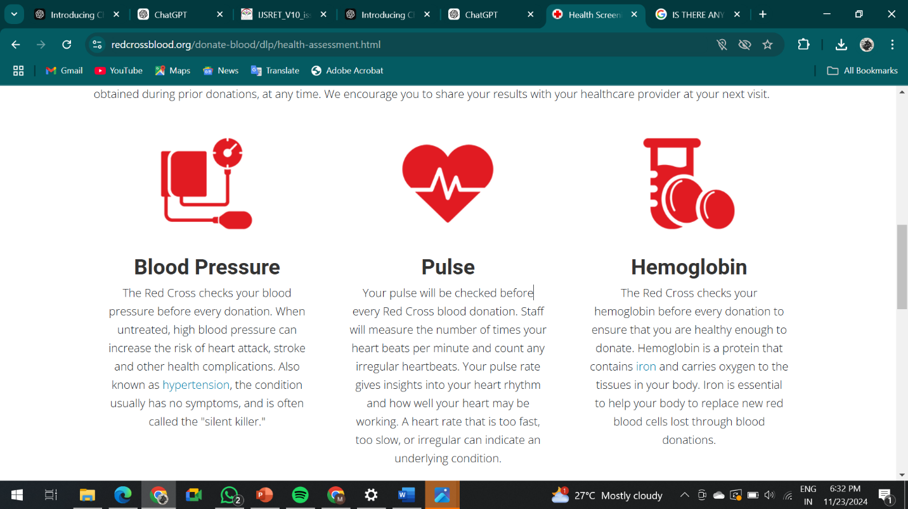

Fig 4.4

**5.SYSTEM FEATURES:**

System features for blood donors focus on enhancing their engagement, providing convenience, ensuring safety, and promoting a consistent blood donation process. The donor registration feature allows individuals to create personal profiles, where they can input essential details like their medical history, blood type, contact information, and preferred donation locations. This information is crucial for tracking eligibility and ensuring the donor's health and safety. Eligibility checks are another important system feature, where the system automatically determines if a donor is eligible based on factors like age, weight, health status, and the time elapsed since their last donation.

This ensures that donors meet the necessary criteria and that their donations are safe for both them and recipients. The donor dashboard is a personalized area where individuals can track their donation history, see upcoming eligibility dates, and access relevant health information. This feature keeps donors informed about their past contributions and the next time they are eligible to donate, fostering continuous engagement. Event notifications and blood drive alerts keep donors aware of local donation events, urgent requests for specific blood types, or blood shortages in their area. These notifications are typically sent through SMS, email, or push notifications, making sure that donors are informed in real-time, encouraging them to donate when needed.

A scheduling system allows donors to book convenient donation appointments at nearby blood banks or hospitals. This feature improves the donation experience by offering flexible timeslots and ensuring that donors can donate at their convenience. Additionally, reminder and alert systems notify donors about upcoming donation appointments, eligibility for their next donation, or important events. These reminders ensure that donors don't forget their scheduled donations and help maintain regular donation schedules. Donation history and certificates allow donors to view a record of their past donations and receive acknowledgments for their contributions. This feature can be motivating, as donors can track their impact over time and receive certificates or digital rewards recognizing their efforts.

1. **Donor Registration & Profile Management**

Donor Registration and Profile Management is the first step in the blood donation process. When a new donor wishes to contribute, they create an account on the blood donation platform, providing essential information such as their name, age, blood type, contact details, and medical history. This profile allows the system to assess their eligibility and ensure they meet the required health criteria for donation. Additionally, donors are asked to provide information about their past donations, including frequency and any previous health conditions that may affect their ability to donate. Once registered, donors can log in to update their profile, track their donation history, and manage their contact preferences. This feature is crucial for tracking donor eligibility, sending reminders for upcoming donations, and maintaining an accurate record of the donor’s contributions, which can also help in future health assessments and emergency situations. Profile management ensures smooth communication and engagement with donors.

* **Feature:** Donors can create and manage their personal profiles, including medical history, blood type, and contact details.
* **Example:** Donors enter basic information like name, age, weight, and health status. The system stores this data and updates it when necessary.

This phase will manage by the hospitals and blood bank



Fig 5.1

**2.Eligibility Check:**

Eligibility for blood donation is typically checked through a combination of automated systems and manual assessments. When a donor registers, the system collects key information such as age, weight, medical history, and previous donation records. Based on these details, the system automatically checks if the donor meets the basic requirements, such as being between 18 and 65 years old, weighing at least 50 kg, and having good health. Additionally, a pre-donation screening is performed, including checking blood pressure, hemoglobin levels, and vital signs like temperature and pulse rate. The system can also flag any disqualifying conditions, such as recent illnesses, medications, or high-risk behaviors. If a donor is eligible, they receive a confirmation message. If not, the system explains why the donor isn't eligible at that time, like having donated recently or having medical issues that disqualify them temporarily.

* **Feature:** The system automatically checks if a donor is eligible to donate based on health conditions, the time since their last donation, weight, and age.
* **Example:** If a donor is eligible to donate blood, the system shows them the "eligible" status; otherwise, it provides reasons (e.g., "you last donated 6 weeks ago, please wait 2 more weeks”)

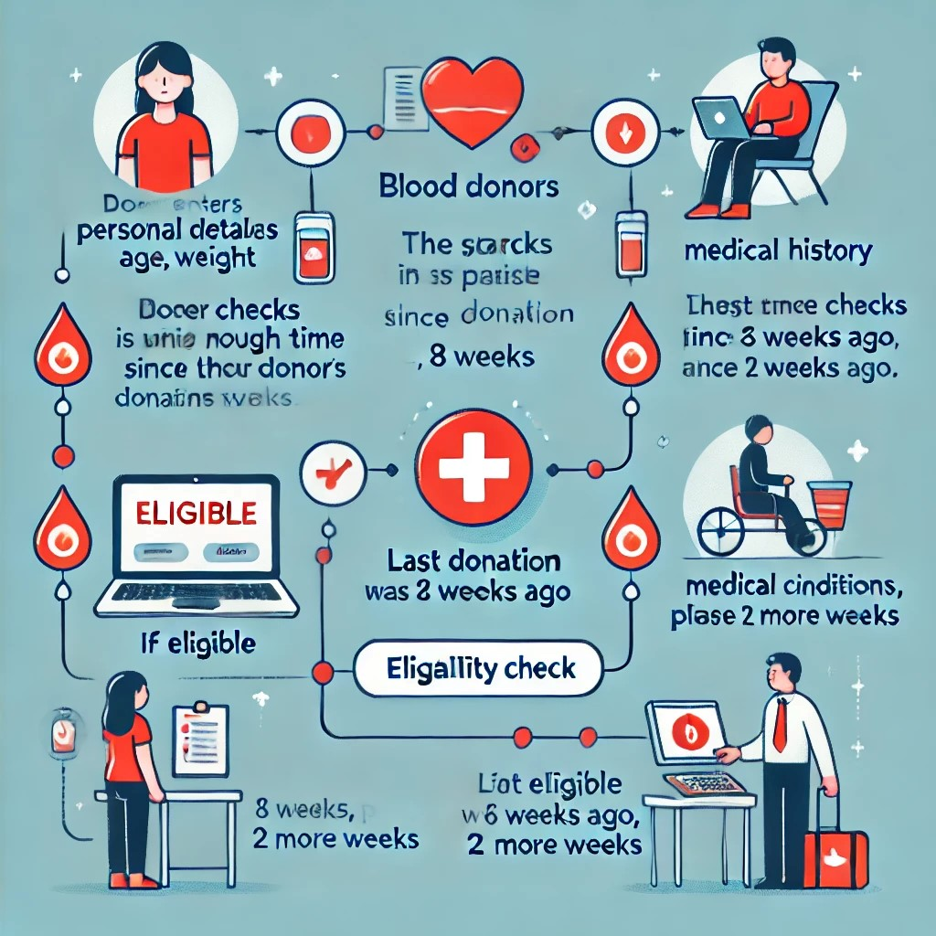

1. **Donor Dashboard:**

The Donor Dashboard is a personalized feature within a blood donation system that allows donors to track their donation history, monitor eligibility, and stay engaged with upcoming opportunities. After logging in, donors can view a summary of their past donations, including dates, types of blood donated, and the locations where they donated. The dashboard also displays information about their eligibility status, such as when they can donate again based on the time elapsed since their last donation. Donors can receive reminders or notifications about upcoming donation events, blood drives in their area, or urgent needs for specific blood types. The dashboard may also show health tips, provide easy access to appointment scheduling, and offer a platform for donors to update their contact information. By centralizing this information in one location, the donor dashboard fosters a better connection with the donation process, encouraging repeat donations and helping manage donor engagement effectively.

* **Feature:** A personalized dashboard where donors can track their donation history, eligibility, and upcoming donation opportunities.
* **Example:** Donors can see the number of times they have donated, their blood type, and upcoming eligibility dates

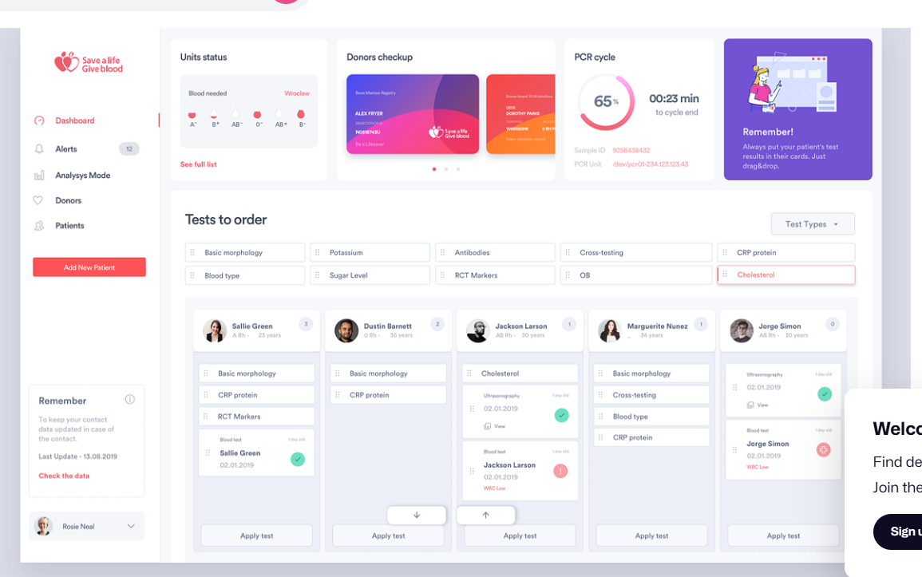

Fig 5.3

1. **Event Notifications & Blood Drive Alerts:**

Event Notifications and Blood Drive Alerts are vital features ina blood donation system, designed to keep donors informed and engaged. These notifications alert donors about upcoming blood drives, community donation events, or urgent requests for specific blood types in their area. Delivered via SMS, email, or app notifications, these alerts ensure donors are aware of opportunities to contribute and respond promptly in emergencies. For instance, donors might receive a message about a scheduled blood drive at a nearby hospital or an urgent request for O-negative blood for a critical patient. The system can personalize alerts based on the donor’s location, blood type, and availability. Additionally, event notifications provide details like the event's date, time, and venue, making it convenient for donors to participate. By keeping donors informed and engaged, these features help maintain a steady blood supply, encourage timely donations, and strengthen the bond between blood banks and their donor community.

**Feature:** Donors receive notifications about local blood donation events,urgent requests for specific blood types, or nearby blood drives.

* **Example:** Donors get SMS, email, or app notifications about blood drives scheduled in their area, or they receive alerts for urgent blood requirements.

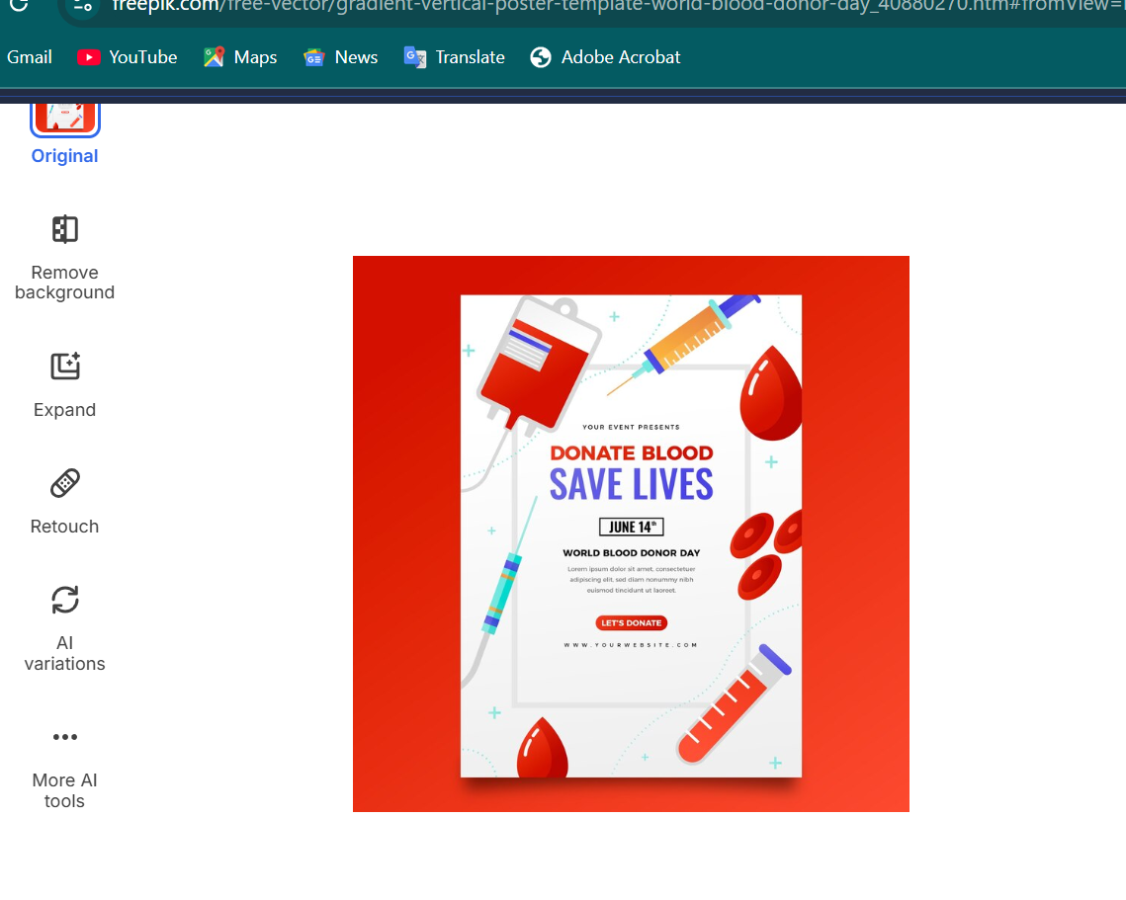

**Reminders & Alerts:**

Reminders and Alerts are essential features in a blood donation system to keep donors engaged and informed. These notifications remind donors of upcoming appointments, eligibility dates, or nearby donation events. For example, donors might receive a reminder three days before their scheduled donation or an alert when they are eligible to donate again after the mandatory waiting period. Alerts can also inform donors about urgent blood needs or special campaigns. Delivered via SMS, email, or app notifications, these reminders ensure donors stay on track and actively participate. This feature fosters regular donations, improving donor retention and ensuring a reliable blood supply**.**

* **Feature:** The system sends reminders to donors about upcoming appointments, upcoming eligibility dates, or when to donate again.
* 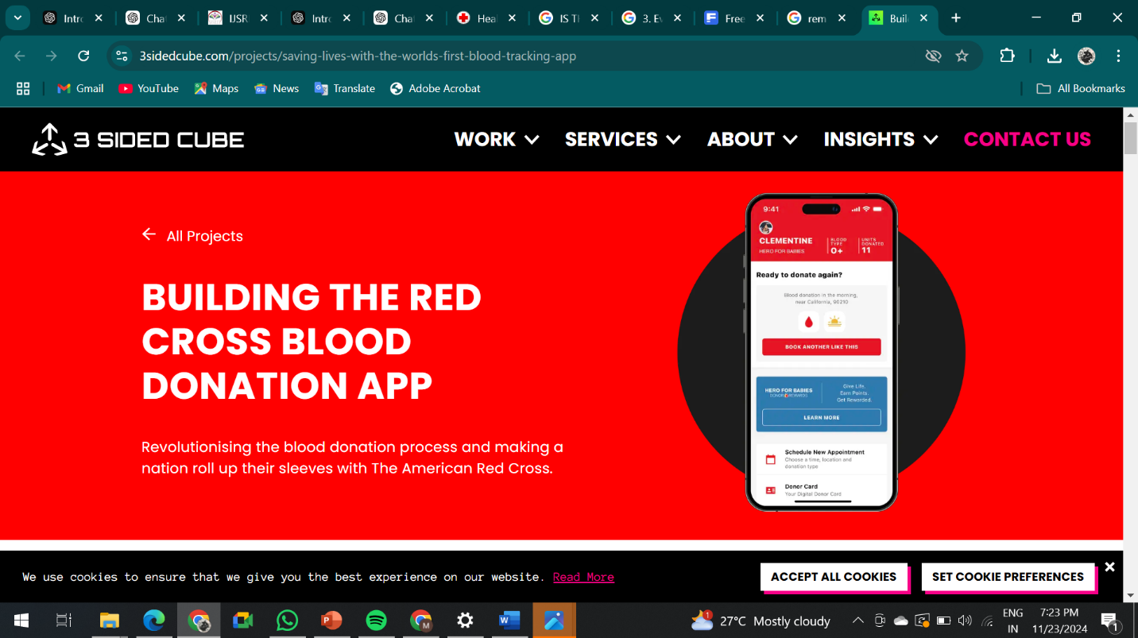**Example:** A donor receives an automatic reminder a few days before their donation appointment or a notification when they’re eligible to donate again after the required waiting period.

**Health Tips and Guidance**

Health Tips and Guidance in a blood donation system aim to support donors before, during, and after their donation journey. This feature provides personalized advice on maintaining good health, such as staying hydrated, eating iron-rich foods, and avoiding alcohol before donating. Donors also receive tips on post-donation care, including resting, drinking fluids, and avoiding strenuous activities. Guidance on managing anxiety or first-time donation jitters is also included. By educating donors about health precautions and recovery practices, this feature ensures a safe and positive donation experience. It helps build trust, encourages repeat donations, and promotes overall donor well-being.

* **Feature:** The system can offer health tips related to blood donation, such as how to prepare for donation, post-donation care, and maintaining good health.
* **Example:** After donating blood, donors might receive advice on hydrating, resting, and avoiding strenuous activities for a certain period.

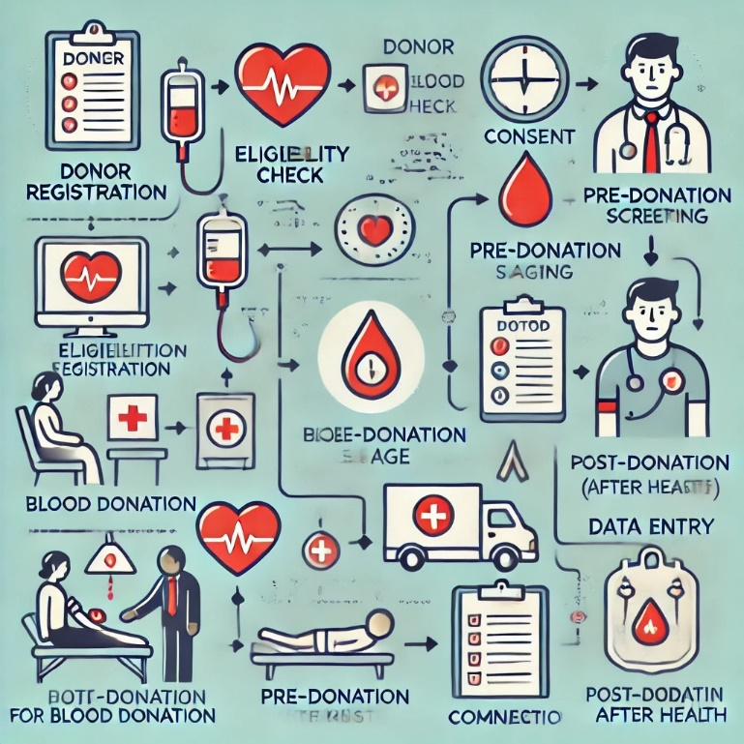

**6**.**IMPLEMENTATION DETAILS**

**6.1 AWS EC2 Configuration for Application Hosting**

1. **EC2 Instance Launch**: Created through the AWS console with an Amazon Linux 2 AMI, which supports the application’s dependencies.
2. **Security Group Setup**: Configured to permit HTTP/HTTPS access for web traffic and SSH for administrative access. The MySQL port is also opened but limited to secure interactions between EC2 and RDS.
3. **Elastic IP Assignment**: Ensures a stable IP address for public access.

| **Setting** | **Configuration Details** |
| --- | --- |
| Instance Type | t2.micro |
| AMI | Amazon Linux 2 |
| Security Group Rules | HTTP (80), HTTPS (443), MySQL (3306) |
|  |  |

* EC2 Setup Workflow (placeholder for image) outlines the steps for launching, configuring, and managing the EC2 instance.

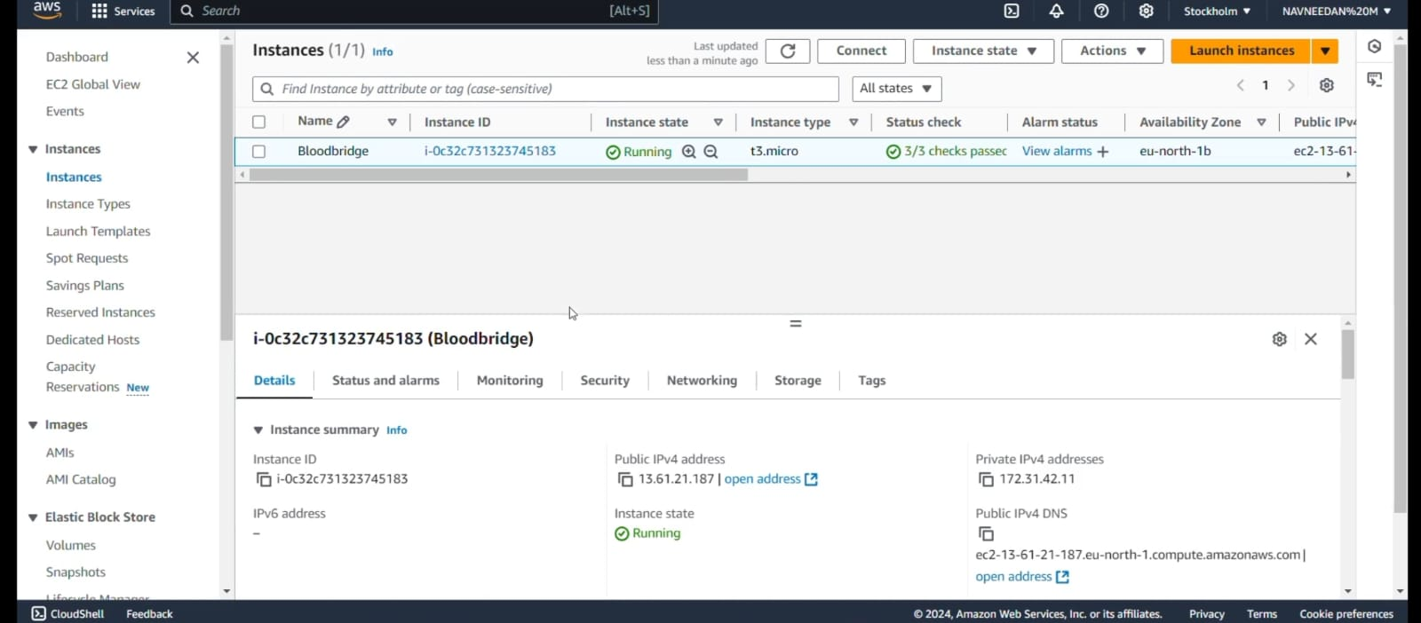

**6.2 AWS RDS Configuration for MySQL Database**

1. **Database Creation**: Configured through RDS with MySQL engine, appropriate security settings, and an initial database name (bloodbank).
2. **Security Group and VPC**: Ensured compatibility with EC2 by placing both in the same VPC, restricting database access to only the application server.

| **RDS Configuration** | **Details** |
| --- | --- |
| Engine | MySQL |
| Instance Type | db.t2.micro |
| Security Settings | Private subnets with restricted access |
|  |  |

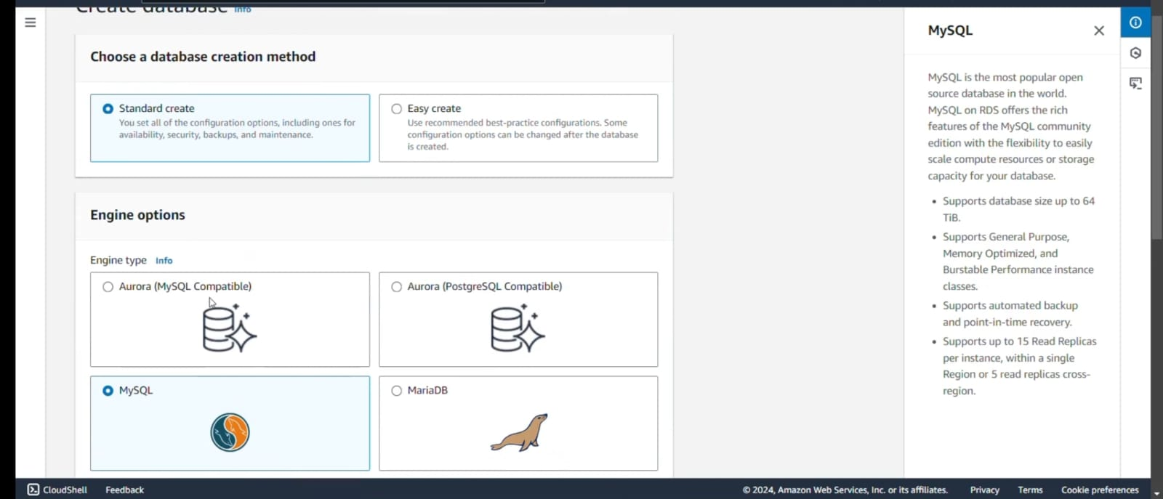

**6.3 Front-End and Back-End Integration**  
The front-end, developed in HTML/CSS/JavaScript, is connected to the Flask-based backend. Flask manages routing and data handling between the user interface and MySQL database, where interactions (e.g., blood request submissions, inventory updates) are recorded and displayed in real-time.

**5.4 Database Design**  
Tables include:

* **Users**: Stores donor and admin information.
* **Blood Requests**: Tracks requests, status, and priority.
* **Inventory**: Maintains blood type quantities for quick updates by blood banks.

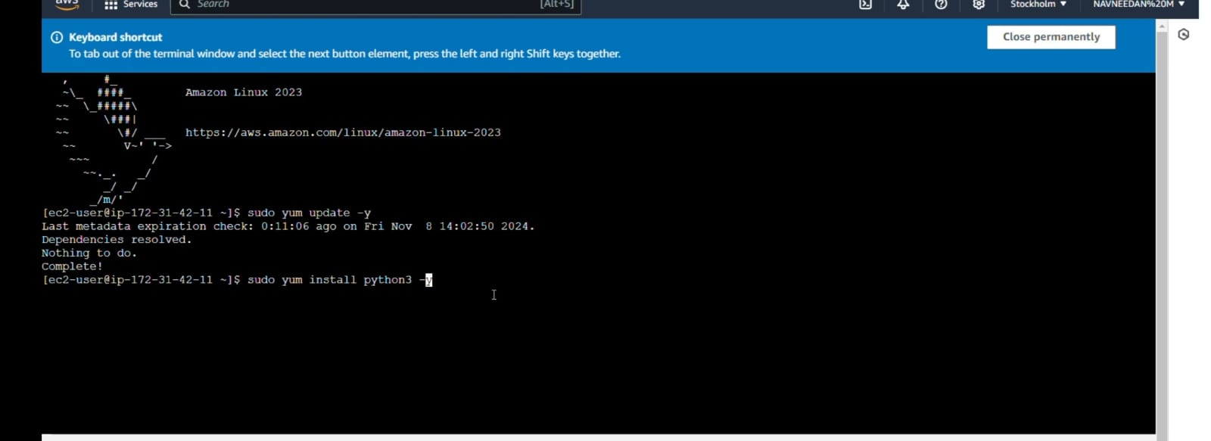

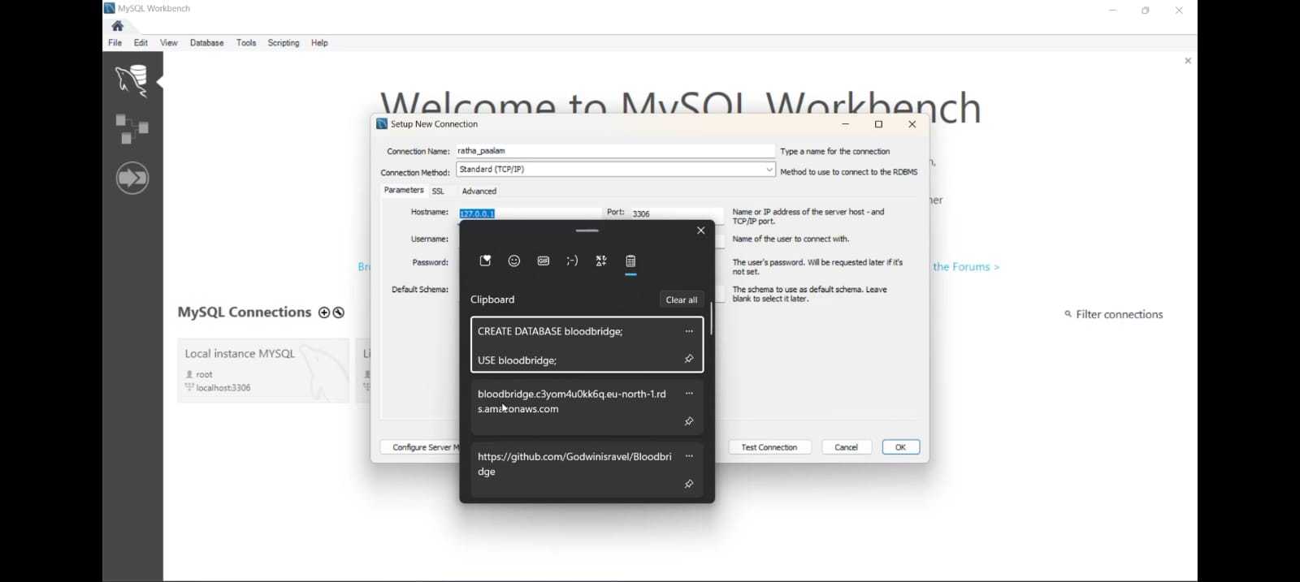

**7.TESTING AND OPTIMIZATION**

**7.1 Functional Testing**  
Each module, from user registration to inventory updates, underwent rigorous testing to ensure accurate functionality:

* **Registration and Login**: Tested for valid and invalid input cases.
* **Blood Requests**: Verified data submission, retrieval, and update accuracy.

**7.2 Database Optimization**  
Optimization techniques, such as indexing frequently queried fields (e.g., user IDs, blood types), improved database response times. Additionally, reducing redundant queries minimized server load.

**7.3 Load Testing**  
Simulated high user volumes to evaluate EC2 and RDS scalability. Results indicated stable performance under expected load, and additional load balancers may be added as demand grows.

**7.4 Security Testing**  
Conducted HTTPS and data encryption tests to secure sensitive information and applied access control policies, ensuring restricted access to the RDS database only from authorized sources.

| **Test Type** | **Outcome Summary** |
| --- | --- |
| Functional Tests | Passed for all primary features |
| Load Testing | Stable performance under 500 concurrent users |
| Security Tests | Verified secure HTTPS connections and restricted access |

**SAMPLE USER REGISTRATION SCREEN**

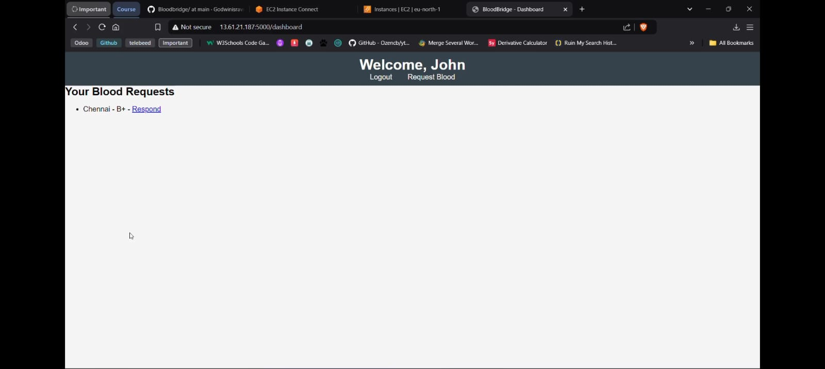

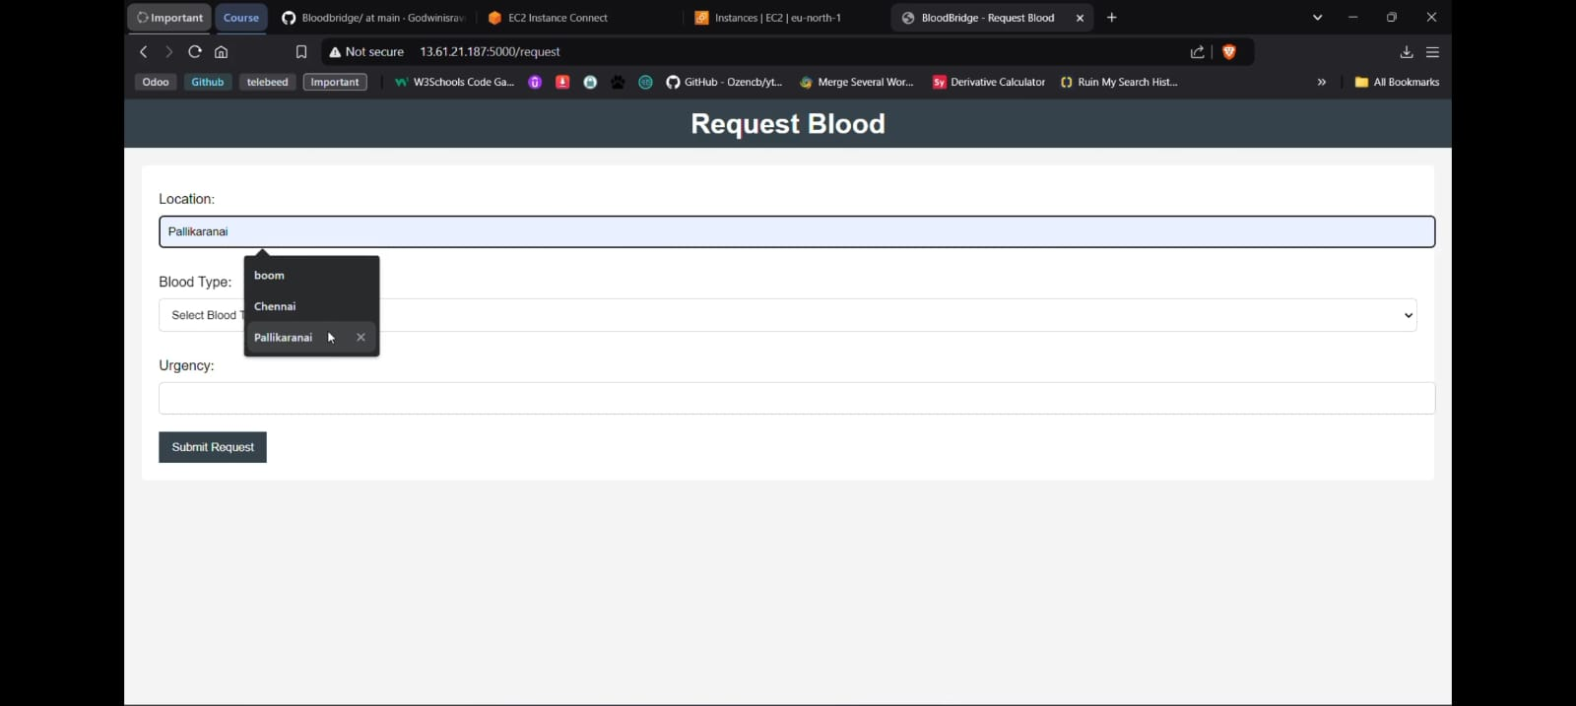

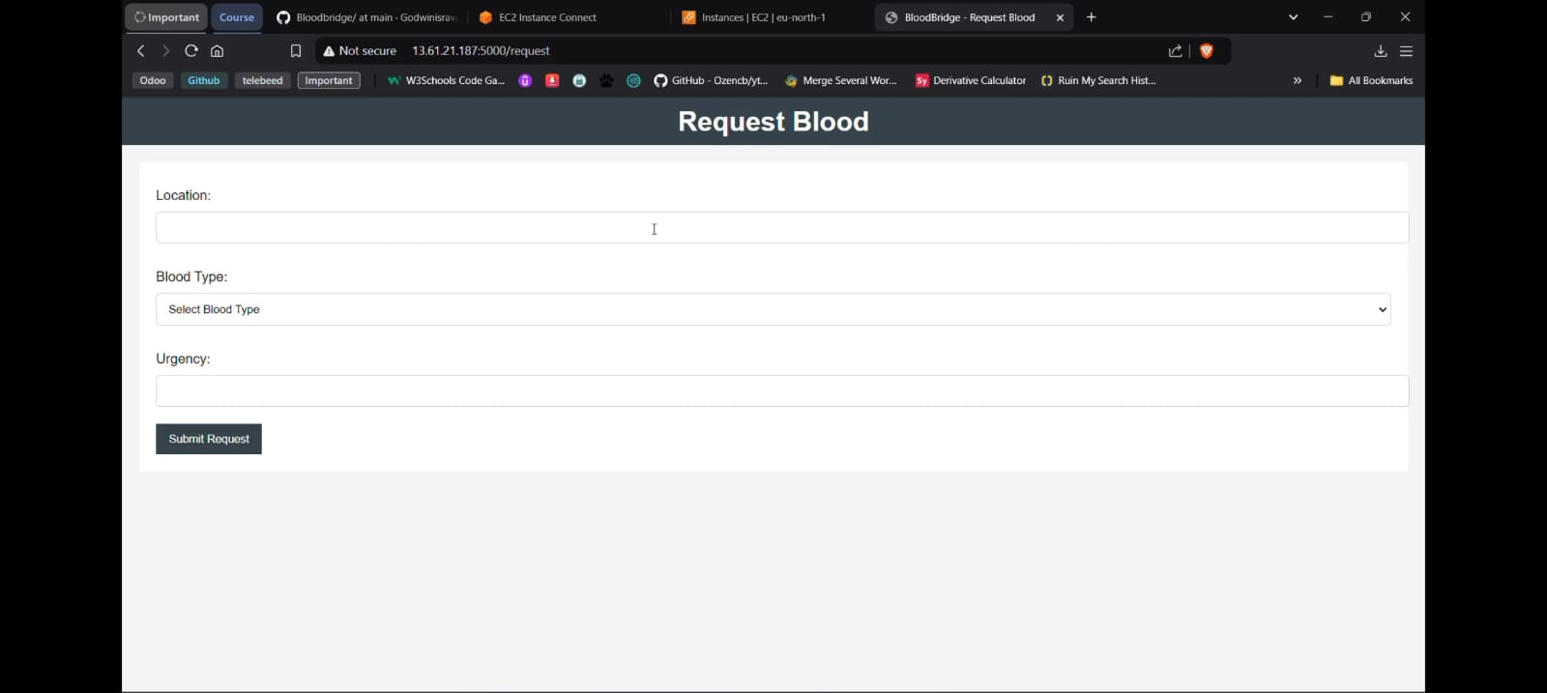

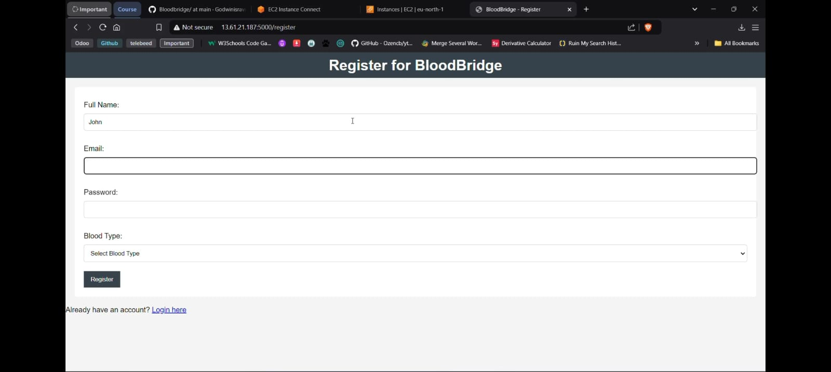

**8.CONCLUSION**

**8.1 Summary**  
BloodBridge successfully demonstrates a scalable, cloud-based solution to streamline blood donation logistics. By leveraging AWS infrastructure, the application optimally connects hospitals, donors, and blood banks, enabling prompt response in emergencies and efficient resource management.

**8.2 Future Work**  
Potential future developments include:

* **Integration with mobile notifications**: Expanding to SMS and push notifications.
* **AI Integration**: Using AI algorithms to predict demand based on historical data, assisting hospitals and blood banks in inventory planning.
* **Regional Expansion**: Adapting BloodBridge for deployment in different geographical locations to facilitate a larger network of donors and recipients.
* User Dashboard Interface (placeholder for image) displays how users can navigate requests and view their respective functions based on roles (e.g., donor, hospital admin).

9.REFERENCE

1. Ariponnammal, S., & Natarajan, S. (1994). Transport Phenomena of Sm Sel – X Asx. *Pramana – Journal of Physics*, 42(1), 421–425.
2. Barnard, R.W., & Kellogg, C. (1980). Applications of Convolution Operators to Problems in Univalent Function Theory. *Michigan Math J.*, 27, 81–94.
3. Shin, K.G., & McKay, N.D. (1984). Open Loop Minimum Time Control of Mechanical Manipulations and its Applications. *Proc. Amer. Contr. Conf.*, San Diego, CA, 1231–1236.